DTSC 671: AI Solutions in the Cloud

SUBMISSION TEMPLATE:
Sentiment Analysis with Amazon Comprehend

Select File > Make a copy to edit the template and add your screenshots. Download the completed template as a PDF document to submit to Brightspace.

In every screenshot, include your AWS username that appears in the upper right corner. Example:

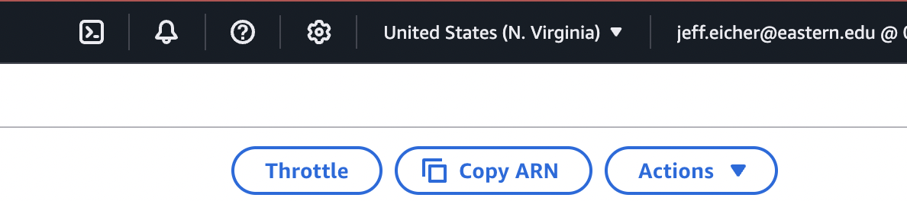

If any one screenshot is missing this identification, the entire assignment will be scored no higher than 70%.

Points totals are provided at the start of each question. You score either full credit or 0 points; there is no partial credit for each question.

Curtis Nielson
DTSC-671

- [10 points] In the space below, provide a screenshot of the SQS queue.

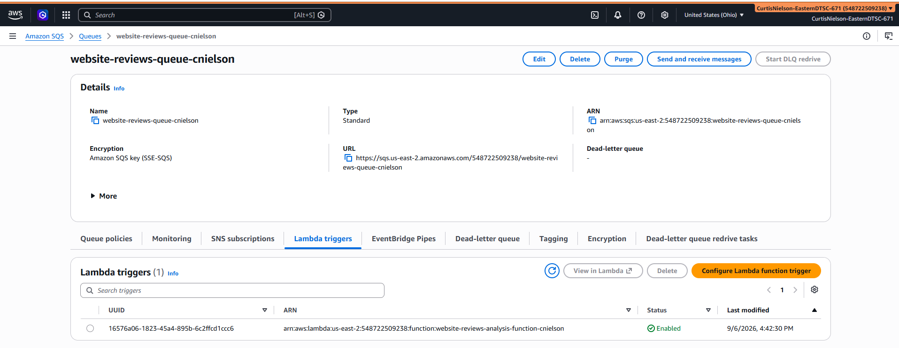

- [10 points] In the space below, provide a screenshot of the SNS topic.

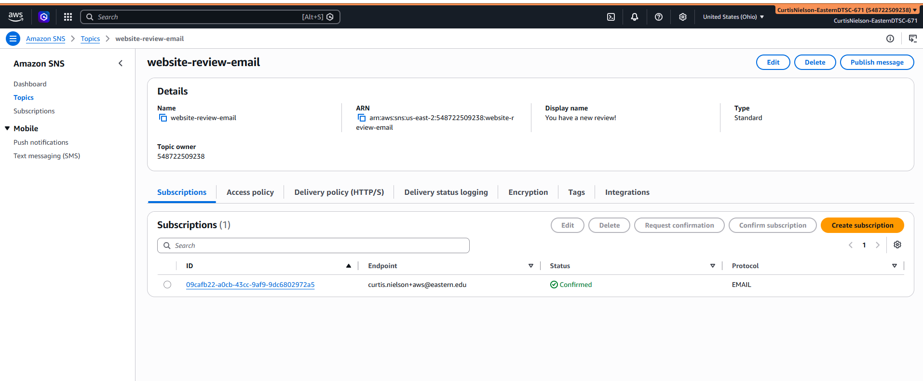

- [10 points] In the space below, provide a screenshot of the Lambda diagram, which shows the SQS trigger and the SNS destination.

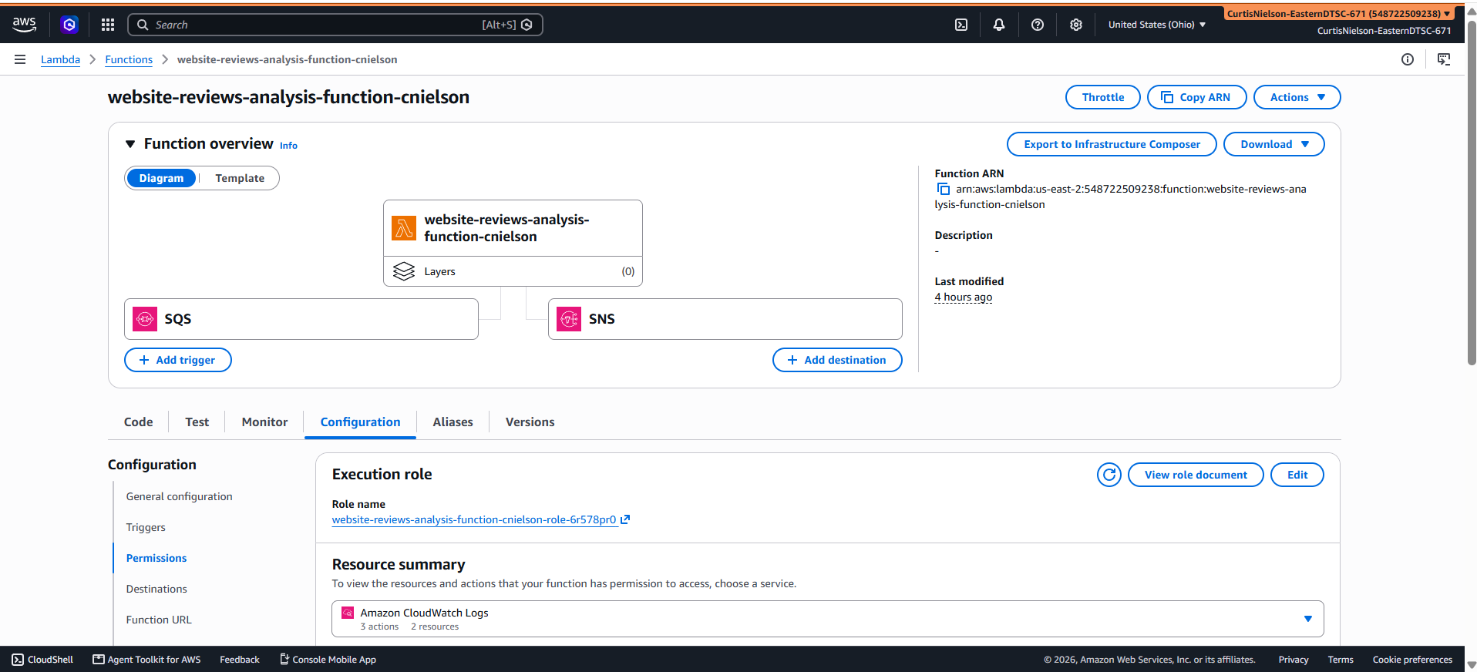

- [10 points] In the space below, provide both a screenshot of the beginning of your Lambda code with your account showing, then copy-paste your full lambda code below the screenshot.

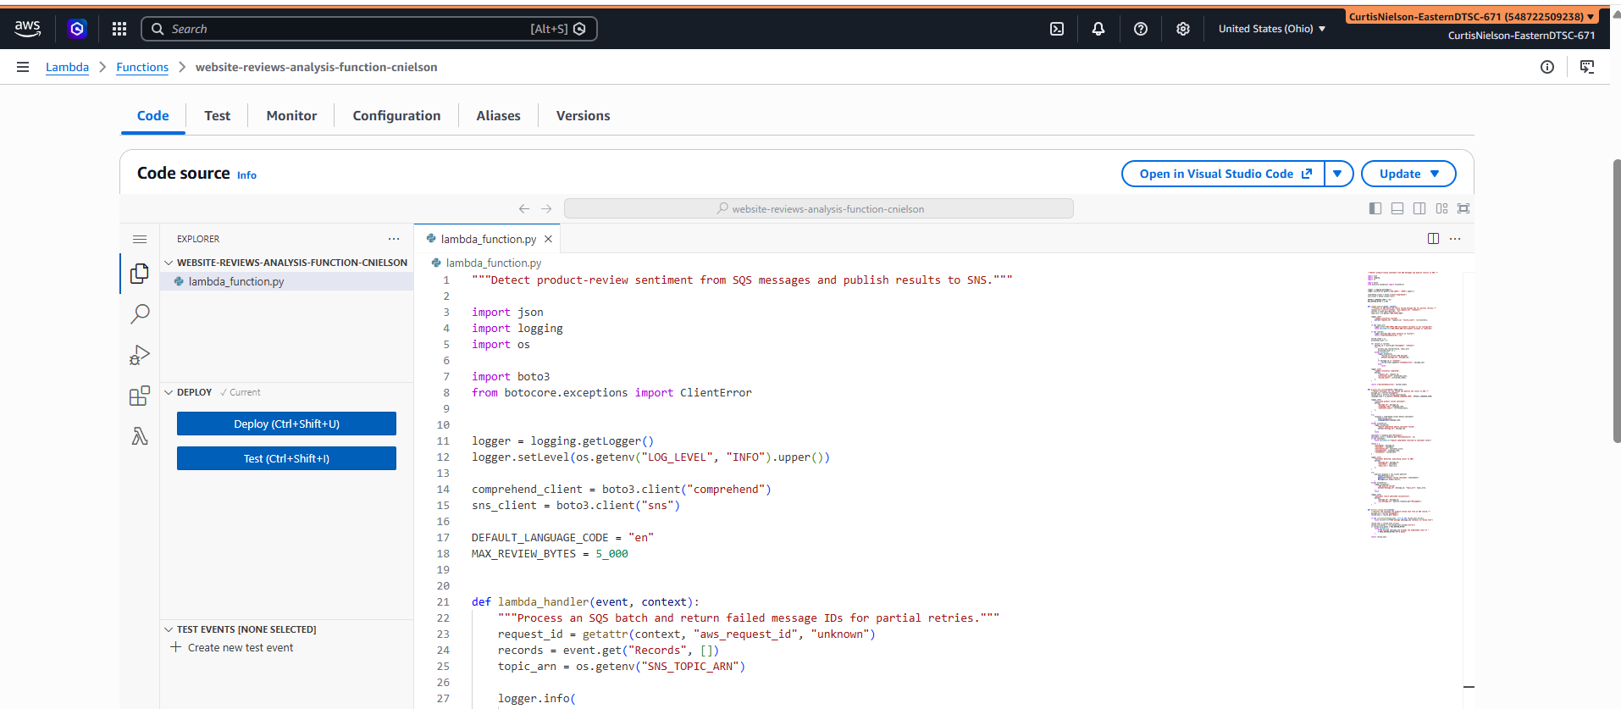

"""Detect product-review sentiment from SQS messages and publish results to SNS."""

import json
import logging
import os

import boto3
from botocore.exceptions import ClientError

logger = logging.getLogger()
logger.setLevel(os.getenv("LOG_LEVEL", "INFO").upper())

comprehend_client = boto3.client("comprehend")
sns_client = boto3.client("sns")

DEFAULT_LANGUAGE_CODE = "en"
MAX_REVIEW_BYTES = 5_000

def lambda_handler(event, context):
"""Process an SQS batch and return failed message IDs for partial retries."""
request_id = getattr(context, "aws_request_id", "unknown")
records = event.get("Records", [])
topic_arn = os.getenv("SNS_TOPIC_ARN")

logger.info(
"Lambda invocation started",
extra={"request_id": request_id, "record_count": len(records)},
)

if not topic_arn:
logger.error("SNS_TOPIC_ARN environment variable is not configured")
raise RuntimeError("SNS_TOPIC_ARN environment variable is required")

if not records:
logger.warning("SQS event contains no records")
return {"batchItemFailures": []}

failed_items = []
processed_count = 0

for record in records:
message_id = record.get("messageId", "unknown")
try:
process_sqs_record(record, topic_arn)
processed_count += 1
except Exception:
logger.exception(
"Failed to process SQS message",
extra={"message_id": message_id},
)
if message_id != "unknown":
failed_items.append({"itemIdentifier": message_id})
else:
raise

logger.info(
"Lambda invocation completed",
extra={
"request_id": request_id,
"processed_count": processed_count,
"failed_count": len(failed_items),
},
)

return {"batchItemFailures": failed_items}

def process_sqs_record(record, topic_arn):
"""Detect sentiment for one review and publish the result to SNS."""
message_id = record["messageId"]
review_text = extract_review_text(record)
language_code = os.getenv("REVIEW_LANGUAGE_CODE", DEFAULT_LANGUAGE_CODE)

logger.info(
"Analyzing product review sentiment",
extra={
"message_id": message_id,
"language_code": language_code,
"character_count": len(review_text),
},
)

try:
response = comprehend_client.detect_sentiment(
Text=review_text,
LanguageCode=language_code,
)
except ClientError:
logger.exception(
"Amazon Comprehend detect_sentiment failed",
extra={"message_id": message_id},
)
raise

sentiment = response.get("Sentiment")
sentiment_score = response.get("SentimentScore", {})
if not sentiment:
raise RuntimeError("Amazon Comprehend returned no sentiment value")

result = {
"messageId": message_id,
"sentiment": sentiment,
"sentimentScore": sentiment_score,
"languageCode": language_code,
"reviewText": review_text,
}

logger.info(
"Sentiment detected; publishing result to SNS",
extra={
"message_id": message_id,
"sentiment": sentiment,
"topic_arn": topic_arn,
},
)

try:
publish_response = sns_client.publish(
TopicArn=topic_arn,
Subject=f"Product review sentiment: {sentiment}",
Message=json.dumps(result),
)
except ClientError:
logger.exception(
"SNS publish failed",
extra={"message_id": message_id, "topic_arn": topic_arn},
)
raise

logger.info(
"Sentiment result published successfully",
extra={
"message_id": message_id,
"sns_message_id": publish_response.get("MessageId"),
},
)

def extract_review_text(record):
"""Extract and validate the product-review text from an SQS record."""
message_id = record["messageId"]
review_text = record.get("body")

if not isinstance(review_text, str) or not review_text.strip():
raise ValueError(f"SQS message {message_id} contains no review text")

review_text = review_text.strip()
review_size_bytes = len(review_text.encode("utf-8"))
if review_size_bytes > MAX_REVIEW_BYTES:
raise ValueError(
f"SQS message {message_id} exceeds the Comprehend limit of "
f"{MAX_REVIEW_BYTES} UTF-8 bytes"
)

return review_text

- [10 points] In the space below, provide a screenshot of the CloudWatch log streams for your Lambda function. Fit as many as you can in the screenshot.

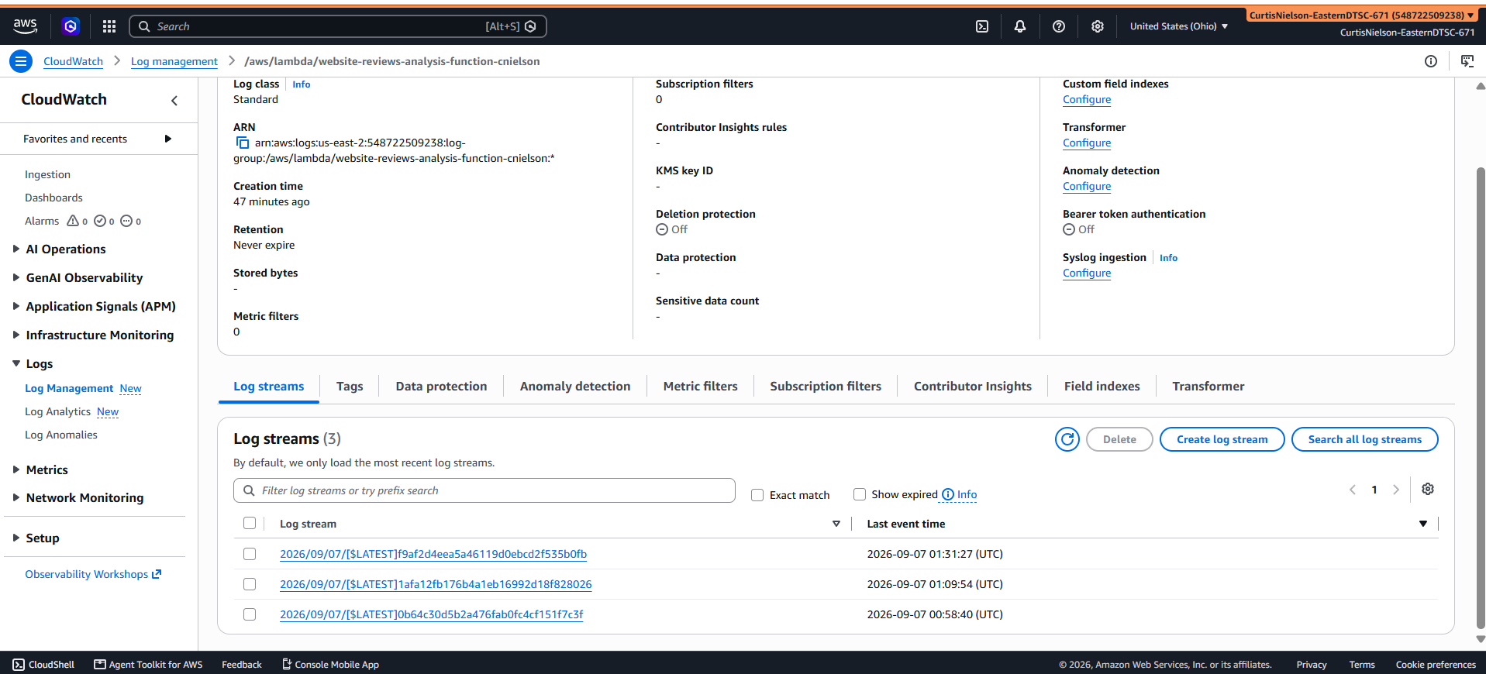

- [10 points] In the space below, provide a screenshot of the CloudWatch stream that functioned without errors for the Lambda function.

Two successful executions are recorded below.

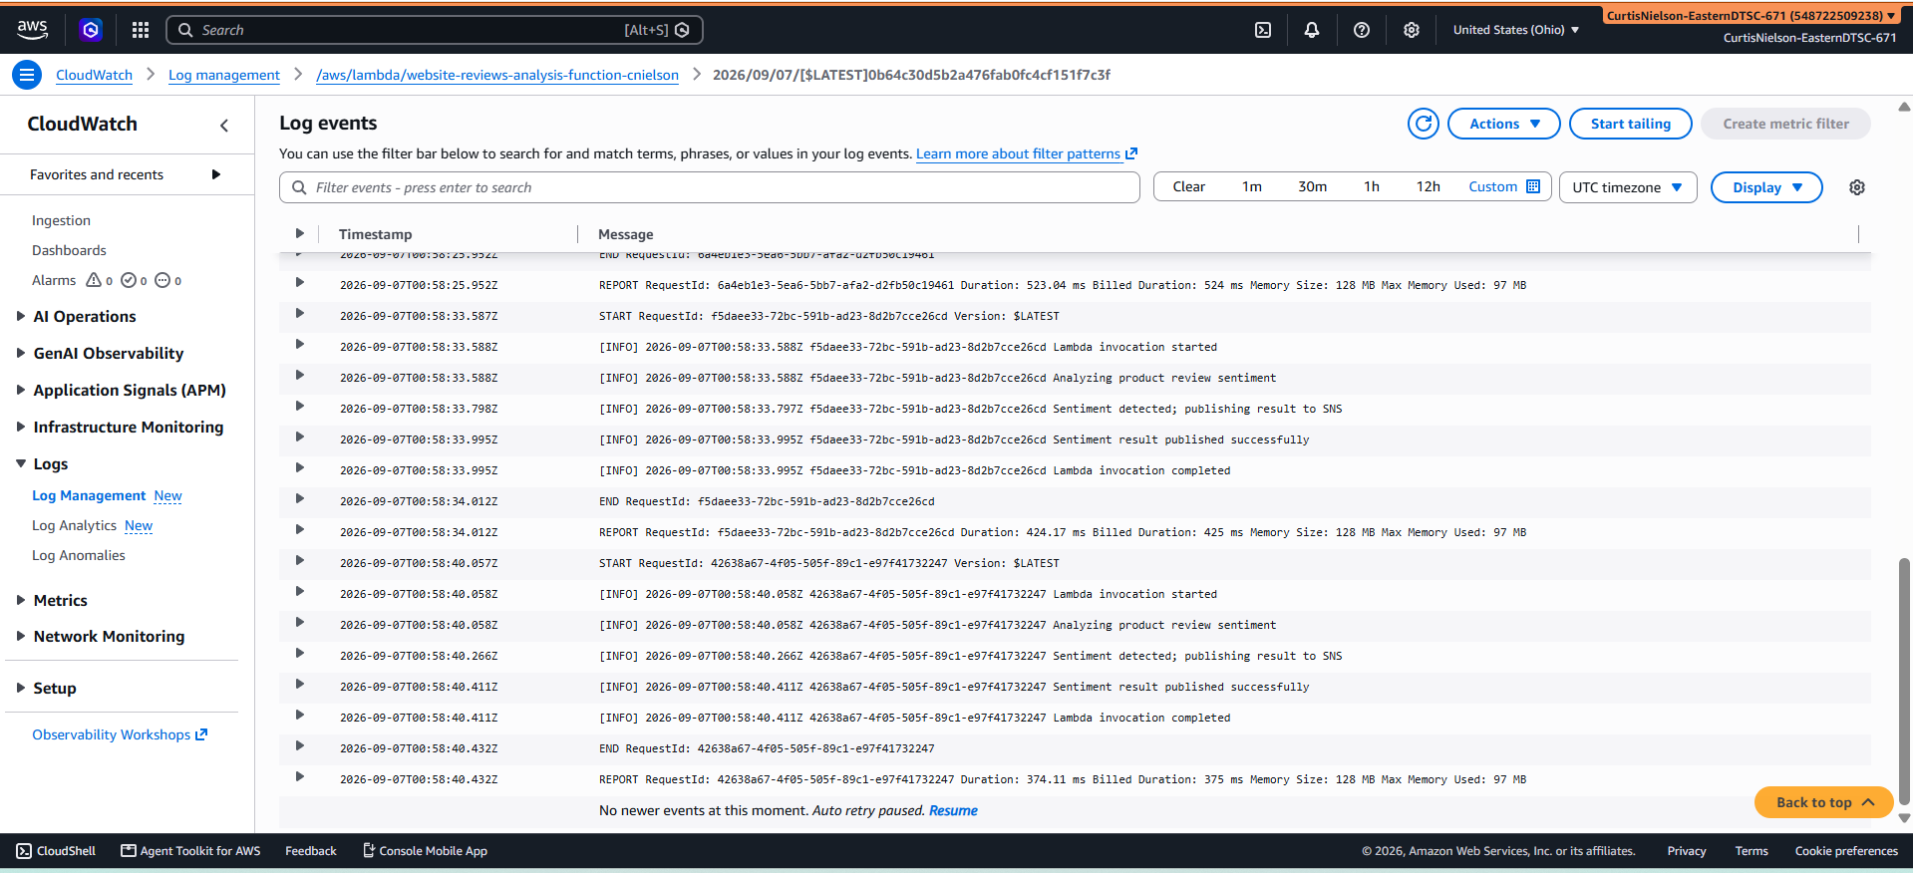
- [10 points] In the space below, provide a screenshot of the review you are testing in the SQS queue.

These three messages were tested

CeraVe hand lotion is great for treating rough, dry skin. It lasts a long time and only takes a few minutes to be absorbed into the skin. I will buy it again.
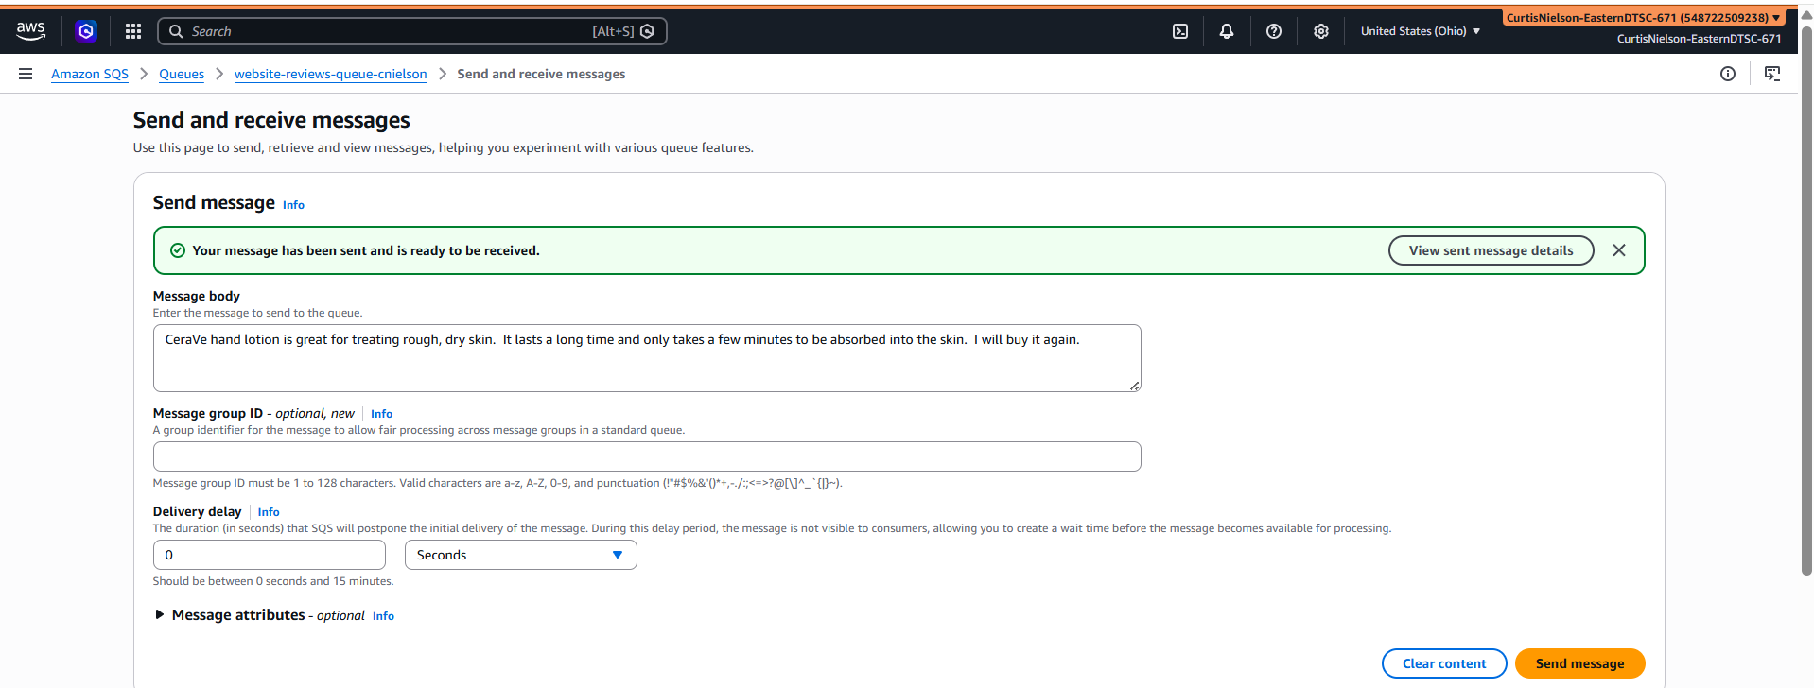

CeraVe hand lotion is only so so for my dry skin. It doesn’t lasts long enough and feels greasy for a while until it is absorbed into the skin. It’s mediocre value for the money.
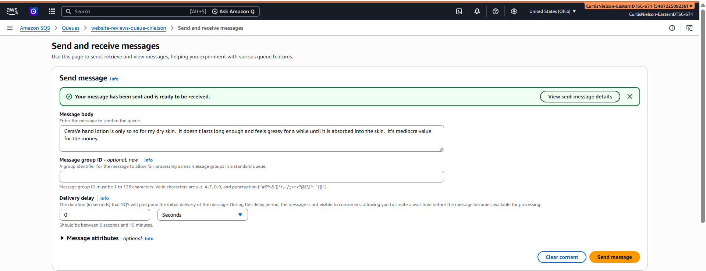
CeraVe hand lotion is not very good for my dry skin. It lasts only a few hours, feels very greasy and takes a long takes a long time to be absorbed into the skin. I'm going to try something else.
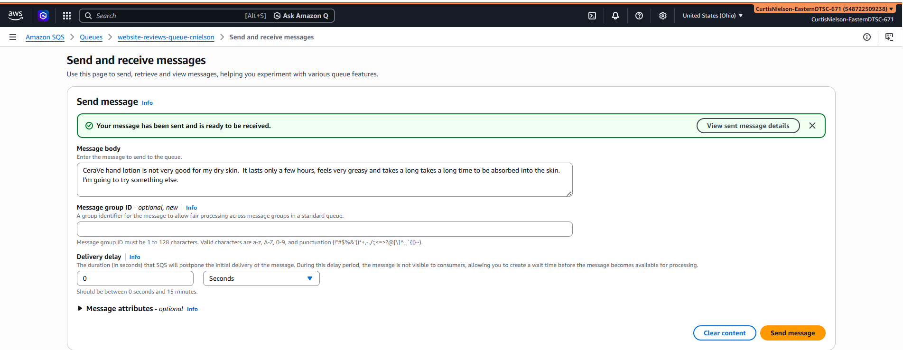

- [30 points] In the space below, provide a screenshot of the email you receive showing both the text of the review and the sentiment (positive, negative, neutral).

The first one is clearly positive

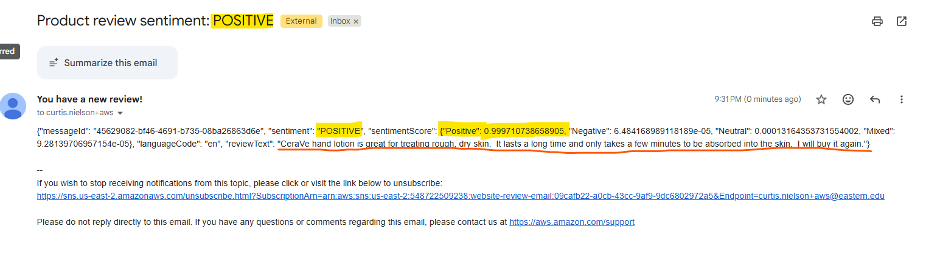

The review where I was going for neutral came out as negative

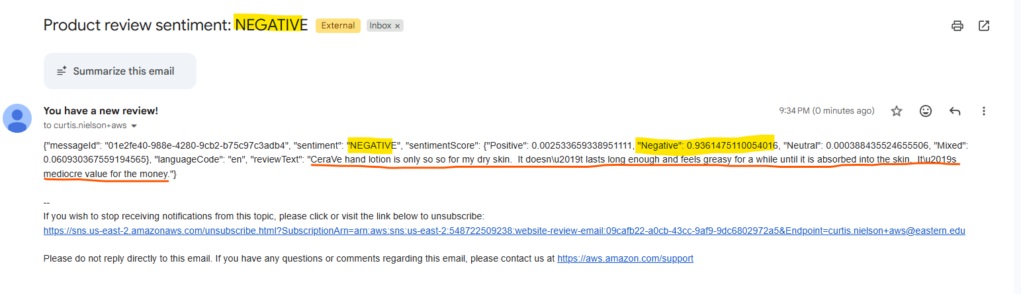

The final review was negative as expected

